

Web & Mobile Programming

Semester – Summer 2020

**NewsHub**

**(Android Project)**

Team 7 - Members

*Yamini Reddy Dontireddy(16293335)*

*Satya Anusha Prattipati (16292575)*

*Arti Nagireddy(16292448)*

*Sandeep Meesala(16299481)*

Contents

**Objective** 3

**Motivation** 3

**Significance** 3

**Features** 3

**Tool & Technologies** 4

**Architecture** 5

**NewsHub Architecture** 6

**API** 6

**Data Store** 8

**Android Studio Components** 9

**Application** 10

**Future Scope** 18

**Challenges** 19

**Learning Outcome** 19

**Expected Project Outcome** 19

**References** 19

**Links** 19

**Acknowledgements** 20

# **Objective**

The main objective of our project is to demonstrate the capabilities of ***Android Platform***, especially developing simple application or use case in **Android** stack with user friendly UI, service layer with data base interaction.

NewsHub, an android mobile app that serves as online news aggregator and news information is classified based on topics such as Business, Science, and Entertainment etc with more features for better user experience such as book marks, videos and email sharing.

# **Motivation**

NewsHub, an open news aggregator from all the online portals and content is published under 5-6 categories such as Business, Science, Technology, Sports and Entertainment etc. This would serve as light weight app without any advertisements and focussed on user preference, authentic news content.

# **Significance**

Vision is to create an mobile app to aggregate the new content based on user preference on the topics and news content would be based on the user view/read analytics from all news portals and news wire services. It gives an edge for this app since the content is based on the news analytics on the likes/comments by the public on any news item.

In addition, app would also provide more choice to users to view news content based on the subjects they like and bookmark it for later reading. This would also show the related news videos from ‘YouTube’ and trending news based on the latest trend across the news portals.

# **Features**

Current phase is a pilot implementation with simple use case with below features,

* News by categories
* Bookmark
* Email sharing to anyone
* News Trend
* News related videos from YouTube
* Integration with News API
* Integration with YouTube API
* Swipe Actions
* Full YouTube controls within Mobile App

# **Tool & Technologies**

* Android
* JAVA
* Room Database
* Retrofit
* RecyclerView
* GitHub

# **Architecture**

Android is an open source, Linux-based software stack created for a wide array of devices and form factors. The following diagram shows the major components of the Android platform. The foundation of the Android platform is the Linux kernel. For example, the Android Runtime (ART) and HAL relies on the Linux kernel for underlying functionalities such as threading and low-level memory management.

**Native C/C++ Libraries**

Many core Android system components and services, such as ART and HAL, are built from native code that require native libraries written in C and C++. The Android platform provides Java framework APIs to expose the functionality of some of these native libraries to apps.

**Java API Framework**

The entire feature-set of the Android OS is available to you through APIs written in the Java language. These APIs form the building blocks you need to create Android apps by simplifying the reuse of core, modular system components and services

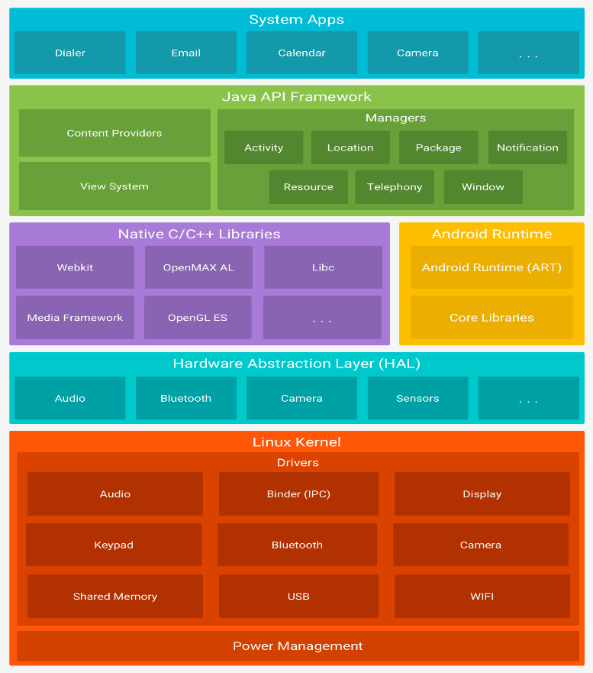

Source: Android Docs

**System Apps**

Android comes with a set of core apps for email, SMS messaging, calendars, internet browsing, contacts, and more. Apps included with the platform have no special status among the apps the user chooses to install. So a third-party app can become the user's default web browser, SMS messenger, or even the default keyboard.

Android platform is chosen for this project and since it provides modular architecture with high levels of abstraction at HAL and ART and developer can work on familiar Java API without worrying about underlying architecture.

# **NewsHub Architecture**

# **API**

Two APIs are used to integrate with News and YouTube.

* **News API**
* **YouTube API**

News API is a simple HTTP REST API for searching and retrieving live articles from all over the web. Singed up in NewsApi account and got the End Points and API secret Keys.

User can search for articles with any combination of the following criteria:

* **Keyword or phrase**. Eg: find all articles containing the word 'Microsoft'.
* **Date published**. Eg: find all articles published yesterday.
* **Source name**. Eg: find all articles by 'TechCrunch'.
* **Source domain name**. Eg: find all articles published on thenextweb.com.
* **Language.** Eg: find all articles written in English.

User can also sort the results in the following orders:

* **Date published**
* **Relevancy to search keyword**
* **Popularity of source**

NewsHub is also integrated with YouTube API to show the relevant videos related to any news item.

**NewsAPI**

**YouTube API**

**Google Console**

# **Data Store**

**Android Room DB**

Room provides an abstraction layer over SQLite to allow fluent database access while harnessing the full power of SQLite.

Apps that handle non-trivial amounts of structured data can benefit greatly from persisting that data locally. The most common use case is to cache relevant pieces of data. That way, when the device cannot access the network, the user can still browse that content while they are offline. Any user-initiated content changes are then synced to the server after the device is back online.

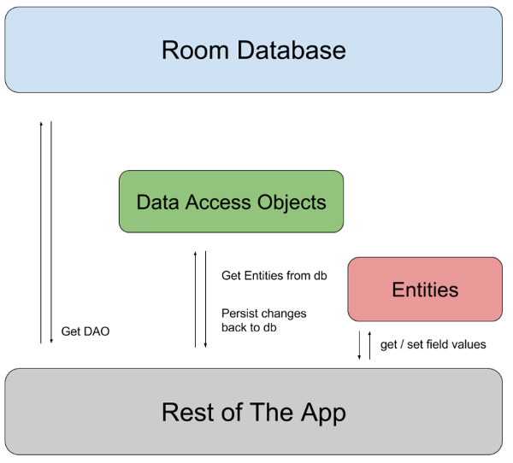

There are 3 major components in Room:

**Database:** Contains the database holder and serves as the main access point for the underlying connection to your app's persisted, relational data.

**Entity:** Represents a table within the database.

**DAO:** Contains the methods used for accessing the database.

# **Android Studio Components**

Application components are the essential building blocks of an Android application. These components are loosely coupled by the application manifest file **AndroidManifest.xml**that describes each component of the application and how they interact.

Below, are the few components used in the project.

* **Activities:** Handles the user interaction to the smart phone screens.
* **Services:** Handles the background processing.
* **Manifest:** Configuration file for the application.
* **Resources:** Hold the External elements such as strings, drawable , fonts ,etc.
* **Layouts:** handles and controls the screen appearance’s.
* **Intents:** Handles the navigation.

# **Application**

Application is developed using Java/XML to align with overall architecture and responsive UI that is adaptable to all screens.

**Front End Overview** – Application contains below screens for the ease of use and designed intuitively based on cognitive needs.

**Home Screen** – Swipe menu with colorful UI designed to improve the app navigation.

**News Home:** This screen contains news categories and news items are grouped under above categories and this is extendible to add more news categories.

**Swipe Action**

**Business News Tab :**

News grouped under any specific category is displayed in the above screen.

**Sports News Tab :**

**Technology News Tab :**

**Health News Tab :**

**Science News Tab :**

**Bookmarks Screen:** User can book mark any news link and read it later.

**Email Sharing:** Users can share the news articles through email and link would be shared with recipient.

**YouTube Videos:**  User can view news related videos directly in the app with all controls just like watching in YouTube platform.

**Trending New:** Trending news articles are displayed in Trending screen to know about the latest news trend.

**Emulator:** There are various different types of emulators available, which can be installed and can be used as Android devices.

**Android App Search:** After installation, search for the app “News Hub” as below.

# **Future Scope**

Current implementation covers only the pilot use case that involves basic news aggregation with few useful features like bookmarks, email sharing and relevant video sources from YouTube. This serves as the proof concept for the technical architecture and learning outcome to develop and deploy any apps in Android platform.

This platform is envisioned as an open platform that would be available to all users to receive news based on analytics, trend and users choice of different categories.

It would serve the society in two broad opportunities,

* To improve overall reach of right news based on user analytics and choice for wider audience.
* Helps to eliminate fake news items since analytics would identify between authentic vs fake based on views and comments analysis.
* Curated news articles with high reach from genuine scholars and journalist would get better attention.

Future enhancement would involve below features,

* News aggregation based on source, timelines, key words etc
* Feedback process with comments & ratings
* More video sources other than YouTube, live and videos from news channels.
* Multilingual / Unicode

# **Challenges**

* Conceptualization of Idea and the application with focus on future business model.
* Use case design and architecture based on Android Platform.
* Integration of APIs with Front end and DB.
* All of the team members are new to Android Platform and Studio, hence there was a learning curve to build this use case.
* New to use Room DB, Emulators – so, faced initial hiccups while developing the application.

# **Learning Outcome**

* Helped to understand Android Mobile platform well and being new to Android, learned to develop the end – to – end application successfully.
* Being new to mobile development and using emulators, understood and had hands on experience about developing Mobile Apps. Also, ultimately this project experience gave us an opportunity to ideate and develop an App.
* Gained enormous confidence to work on real time projects after this project and can successfully work as a team too.

# **Expected Project Outcome**

This use case and the reference implementation is a good case study to expand the scope on both technology and functional sides. This can be developed as open app for the use of community to improve the reach and authenticity of news on online and social media platforms.

# **References**

* <https://developer.android.com/reference/android/arch/persistence/room/RoomDatabase>
* <https://medium.com/@soffritti.pierfrancesco/customize-android-youtube-players-ui-9f32da9e8505>
* <https://newsapi.org/account>
* <https://unsplash.com/>
* <https://www.raywenderlich.com/5686-room-db-advanced-data-persistence>
* <https://www.tutorialspoint.com/android/index.htm>

# 

# **Links**

**GitHub Wiki Link:**​

* <https://github.com/yaminireddyd/Web-MobileProgramming---2020Summer/wiki/Mobile_Project(Android)>

**GitHub Project(Source Code) Link:**​

* <https://github.com/yaminireddyd/Web-MobileProgramming---2020Summer/tree/master/Mobile/Mobile_Project>

**VIDEO LINK:**

* <https://umkc.hosted.panopto.com/Panopto/Pages/Viewer.aspx?id=cf6e1206-19bb-4fdb-9ec4-ac0800425c05>

# **Acknowledgements**

We express our sincere gratitude to Professor **“Vijaya Kumari”** for providing us an opportunity to do the Mobile project “News Hub” and also for the guidance and encouragement through out the project.